Quimper Unitarian Universalist Fellowship
Board of Trustees
Meeting Minutes for June 25, 2025 6:00 pm
RE 2/3 and Via Zoom

QUUF MISSION: We join hearts and minds
To learn, to serve, to nurture justice
Holding love at the center of all we are and all we do.

We acknowledge that these waters, mountains, valleys and shorelines are the traditional territory of the S’Klallam and Chemakum peoples. We will work to restore and sustain their homelands and all living beings.

Meeting Called to Order 6:00
Present: Sarah Walker, Peg Hunter, Mary Tucker, Julia Cochrane, Gary Forbes, Dean Carr, Bill Testerman, Megan Cate, Joanna Sanders, Christina Tweed (tech), Jenell DeMatteo; on Zoom: Roseanna Almaee, Reina Garcia; Observer: Henry Amick

Spiritual Practice and Opening
Chalice Lighting

Protocol for observers during virtual or hybrid meetings:
- All non-board members will be muted and video turned off
- Observers may be asked to respond to a question (e.g., parliamentarian for a question on process)
- Invited observers with items on the Agenda may be asked to join when that agenda item is being discussed

Opening Announcements or acknowledgements 6:20
- We will have an Executive Session at 7:40 to update the Board on a Personnel matter.
- Reminder—July 9 4:00 PM Ministry exit interview with Pacific Western District (refer to June 3 email from Sarah Walker for exit questions to review)
- A special appreciation for our out-going BOT members: Mary Tucker and Megan Cate
- A special welcome to Reina Garcia and Joanna Sanders and to our continuing Trustees Bill Testerman and Dean Carr.
- A special surprise gift for Sarah Walker, president extraordinaire, who is remaining on the Board but stepping down from the presidency!
- Check-in –
- Assign process and time observer: None

Motion to Approve Meeting Agenda
Moved: Megan; Seconded: Gary; Roseanna

Consent Agenda
- Approval of Minutes of May 28, 2025 meeting
Moved: Julia; Seconded: Gary; Approved

Standing Reports
- President’s Report – See Attachment A
- (Minister’s Report ) From DFM Beau Ohlgren– See Attachment B
Beau and Christina have organized the Sunday services for summer. Most teams are not meeting during the summer, and RE does multi-age led by Beau for the summer months. Lay leaders are doing the services so as not to dip into ministerial money.
- Treasurer’s Report – See Attachment C
Motion to approve Treasurer’s Report: deficit will be around $35,000 as opposed to $47,000. Rentals have exceeded the budget. The concert series did not meet their goal, but the fundraising goal was reached plus $900. Rentals: AAUW met monthly; the rest was one-time events like weddings and memorials. We are part of Quimper Collective which helps us advertise. There is one more month left before we close the books on the fiscal year. It appears that many of the teams and councils did not spend all the funds allocated to them.
Motion: The Finance committee recommends to the Board for their approval the May 2025 Consolidated Balance Sheet reflecting Total Net Assets of $2,071,058.54 and the May 2025 Operating Fund Income and Expense Statement reflecting Year to Date Excess Income of $12,702.41.
Moved: Mary; Seconded: Peg; Passed unanimously
Motion to dissolve RAMP Committee (At RAMP’s request)
Moved: Mary; Seconded: Megan; Approved

Trustees’ Reports – Congregational Committees
- Endowments – Mary T.
Sandy Tweed has resigned as chair of the committee but is remaining on the committee; no one else has stepped up as lead. Endowments raised $2,831 from tabling for donations. They are considering meeting quarterly rather than monthly. Hopefully, they will have a plan in the fall to request legacy giving from congregants. Endowments is still considering a $50,000 loan if needed. We will revisit this in the fall.
- Nominating Committee – (no report) – Gary F.
Nominating Committee is meeting in July. John is off the committee, as is Share. Kate Kinney, Anne Marie Mende, Anne Weaver, and Kathleen Holt remain on the committee.

Program Council Report – see Attachment E
Information: Governance changes for Growth and Learning: RE program, Widening the Circle Team as a Board committee is a possibility. We need further information on why this should be a Board committee. Further discussion might be appropriate at the Executive Committee meeting.

BREAK 6:55 – 7-00

Board Task Force and Committee Report

- Communications Subcommittee – Peg H. and others
  - Reflections on the Annual meeting:
Floor voting process: actual numbers may only be needed on 2/3 vote items. Those voting against may feel some pressure when voting is public. Ballots in the future should include all issues to vote on at once. Some people feel uncomfortable going up to a standing microphone.
  - Board member anticipated vacations – see Peg at the break or email.
  - Next steps for the new board: a Special Board Meeting will be called in early July. Christina sent out a poll to determine the best date for this meeting. Peg will contact Board members to assess their interest in various roles, including officers and liaisons to Board committees.

- Governance Committee – see Attachment G – Julia C., Roseanna A.
Discussion:
Ministry Coordinating Team: Frances Loubere is interested in talking with the Board. Is this a Board responsibility? To be determined at a future meeting.

Strategic and Long Range Planning Task Forces – update from Executive Committee meeting where Larry clarified the difference between strategic planning (which involves big picture thinking, visioning and dreaming) and long-range planning (which is more about the strategies used to accomplish those goals and make that dream reality). There will be preliminary work this summer about the formation of these task forces, with a goal to form the task force for strategic planning first in the fall.

- Denominational Affairs (no report) – Julia C.
Five people attended GA: Julia Cochrane, Roseanna Almaee, Dena Shunra, John Collins, and Cynthis Becker. Julia and Roseanna will submit a report for the next Board meeting and will do either a blog or an MBR to let congregants know about important votes at GA.

- Personnel Committee (no Report) – Roseanna A.

Update on status of staff and board responsibilities in the absence of a Minister.
Christina and Beau have lined up Sunday services. Supervision of staff falls to the Board. Further discussion will continue at the next Board meeting on 7/24.

Executive Session 7:40
Motion to move to executive session:
Moved: Roseanna Seconded: Gary Approved

Motion to leave executive session:
Moved: Peg; Seconded: Dean; Approved

Motion to ADJOURN
Moved: Dean; Seconded: Julia; Approved

The executive session dealt with a personnel issue.

Extinguishing the Chalice:

<Closing Words>

References

Open Questions for QUUF Vision building from 2021 BoT Retreat

Together how can we better meet the spiritual needs of our community?
How can we create a more unified, diverse, equitable and inclusive
QUUF community for all?
QUUF Board Covenant (revised 9/14/15)
As Board members of the Quimper Unitarian Universalist Fellowship, we will:

- Hold in love all that we do for QUUF and the Board. Love serves to make service on the Board a spiritual experience.
- Listen mindfully and deeply, encourage each other, work toward trusting relationships in order to transcend our individual limitations and achieve a greater result.
- Seek consensus, honoring dissenting opinions. We will speak with one voice about Board decisions once they are made.
- Be prepared to achieve the goals we collectively set, keeping in mind the spirit, cooperation, and joy.
- Resolve our conflicts in a timely manner. Forgive each other and ourselves.
- Speak honestly and be discerning about what needs to be kept confidential.
- Express sincere appreciation of each other.
- Maintain a sense of humor.
- Represent the congregation by listening to their concerns and dreams and by acting in their best interest.
- Be guided by the Seven Principles.

- Updated: 10-11-2024 | Sarah W. | Roseanna | Peg | Julia | Mary | Gary | Megan | Dean | Bill
Number of Assignments
Officers
President | X
Vice President |  | X
Secretary |  |  | X | X
Treasurer |  |  |  |  | X
Executive Team | X | X | X |  | X
Standing Committees
Finance –Treas required by bylaws |  |  |  |  | X
Endowments Treas required by bylaws |  |  |  |  | X
Nominating- Chosen by board members, and is a voting member of committee |  |  |  |  |  | X
Personnel |  | X
Board Committees/Task Forces
Communications |  |  | X
Governance Committee |  |  |  | X
RAMP |  |  |  |  | X |  | X
GOALS-LEADERSHIP
Finance |  |  |  |  | X |  | X
Nominations - Governance |  |  |  |  |  | X
Mission |  |  |  |  |  |  |  | X
Developmental Ministry | X | X
Board Procedures |  |  | X | X
Fellowship Meeting & Annual Meeting | X | X | X | X | X | X | X | X
Pending Committees/Task Forces
Long Range Planning (5-Yr plan) – not yet formed-requires board action
Leadership Dev. Program – not yet formed-requires board action
(1) Treasurer member per bylaws
(2) Elected from Board Members as voting member

Attachment A
President’s Report
June 25, 2025

A major focus of this month was planning, coordinating and conducting the Annual Meeting on June 8. The meeting was well attended and a quorum was established. All four business items that required voting passed without contention from the floor. These included passing our new Vision and Mission statements, revising language changes for two bylaws, revising some language in our Covenant of Right Relations and the proposed Budget for 2025-2026. Included with the materials for participants, there was a form for members to re-visit their pledges and potential gifts in order to improve our financial outlook with additional encouragement from Stewardship Chair Robin Stemen.

The meeting concluded with appreciation for Linda Hart as she completed two years of service to QUUF. She was presented with a memory book and a cash gift.

Other meetings and tasks this month:
- Severance Contract for Linda Hart
- Registering with the UUA Transitions Team for Contract Ministry connections, communications with the Search Team, identifying some contingency plans for Ministry
- Orientation sessions with new board members
- Preliminary communication to set up a Long-Range Planning Committee
- Planning for Staff/Board coordination of responsibilities for the summer
- Preparations for transferring the role of President at the end of the month and communicating pending board projects and tasks
- Researching the role of Treasurer and potential alternative models

It has been my honor to serve as the President of the QUUF Board of Trustees for the past two years. It has been an amazing personal learning experience for me. I have appreciated the collegial relationships with other board members and the work we have done together. I have been encouraged at all times by the supportive work that is done by the board committees and the many times I have been able to receive needed advice. That is also true for the work of our Program Council Teams and the general enthusiasm of the QUUF community that generates so many wonderful opportunities for fellowship, spiritual growth, creativity, social justice and celebration. That energy is inspiring for the shared work of caring for this community and providing for its future. Finally, I want to acknowledge the deep respect and appreciation I have for our staff after having so much direct collaboration with them. We should never take for granted how fortunate we are to have such competent and caring and patient individuals working with our lay leadership.

We belong to an amazing community with an inspiring mission.
With immense gratitude,
Sarah Walker
President, QUUF Board of TrusteesReturn to Agenda
Attachment B
Monthly Minister’s Board Report
Beau Ohlgren Director of Family Ministry/Ministerial
Fill-In Report to the Board
sJune 22, 2025
Right now is big planning time- setting the calendar for next year, training OWL facilitators, recruiting teachers, and doing the whole shift from program year to summer to program year. It’s also a shift in covering ministerial duties and ensuring that the congregation doesn’t feel headless at this moment in time. I felt like I was leaving an intense time, but it just continues in the intensity!
Summer services are planned through August 24th and we have a great line-up of folks that I think will deliver a mixture of interesting services that will keep folks engaged.
Bridging, Annual Meeting, graduations, and shifting into ministerial coverage (which this week includes two weddings because folks love to get married around the solstice!) has been a juggle while also looking forward- shifting ALSO and the RE team over, which I think is a good move and I’m looking forward to being engaged in Community Council, and doing all the summer service scheming as well heading towards the fall. We worked on shifting Opening Sunday to avoid the Wooden Boat Festival as well, which the Program Council decided on for September 14th. The summer is upon us but it feels like the fall is fast approaching!
Quimper Camp
Quimper Camp is always the anchor point of my year- the lead up is intense and months-long, and then I feel directly launched into the end of the program year.
It was a fabulous success this year- 103 people came, our largest yet (by 2, but that counts!) and there was a good mix of old-timers and first-timers. I would still like to increase the number of non-young-family adults that attend, as well as have ministerial/QUUF leadership presence beyond myself there, but overall a strong community builder.
RE, YRUU, and Bridging
RE classes wrapped well, and we are thinking of changing up our class cohorts again this coming year because we have huge a huge glut of 3 to 5 year olds currently, which is a great problem to have! Our teacher teams were strong and enthusiastic this year.
We used parts of Soul Matters for our elementary curriculum and I was not particularly impressed- I would like to continue to have thematic connection between the RE classroom and the pulpit, but the lessons were less engaging and had fewer learning takeaways than I prefer.
Our combined middle-and-high youth group was a success – and we had a masqUUerade with 14 youth for a fancy potluck and dance as our send-off for the year and our two wonderful bridgers, Tommy and Juliette, on June 8.
We are planning on doing an hour of combined middle/high RE before youth group next year to do Neighboring Faiths year of travel and learning with the older kids while also keeping the youth groups together, as they have voiced a preference for that.
Return to Agenda

Attachment C
Treasurer’s Report to the Board

Treasurers Dashboard | May 2025  91% of the year
Membership Data | # serving
- Membership individuals | 297
- Membership Units | 225
- # of Friends | 27
- # of Guest of Record | 240
Total individuals serving (A+C+D) | 564
Pledge Data | # Pledging
Total # of Pledges committed 24-25 | 223
#Membership units pledging | 187
# of Friend units pledging | 14
# of Guest of Record units pledging | 19

Plate YTD Budget
Total $11,980.70 $15,000
BUDGET | YTD 05/25 | Annual Budget
REVENUE
CONTRIBUTIONS | $ 436,442.46 | $ 476,014.00
PROGRAM FEES | $ 22,965.00 | $ 26,970.00
RENTAL | $ 10,633.50 | $ 6,000.00
FUNDRAISING | $ 63,606.40 | $ 57,500.00
INVESTMENT | $ - | $ 20.00
TEMP FUNDS TRANSFER | $ 13,913.08 | $ 10,486.84
Total | $ 547,560.44 | $ 576,990.84
EXPENSES
Staff Wages & Benefits
Minister | $ 107,571.36 | $ 140,751.32
Dir. Family Ministry | $ 85,713.87 | $ 93,715.96
Cong. Admin. | $ 79,039.64 | $ 86,331.88
Office Asst. | $ 22,892.77 | $ 25,120.44
Fac. Coordinator | $ 47,060.64 | $ 50,692.31
Tech/Bookkeeper | $ 74,641.35 | $ 81,846.88
RE & Youth Program & Childcare | $ 8,131.79 | $ 10,785.80
Debt/Mortgage | $ 25,738.46 | $ 28,178.32
Facility & Utilities | $ 24,373.12 | $ 26,208.00
Office & Administration | $ 12,485.89 | $ 16,907.00
Committee Activities | $ 11,554.36 | $ 10,815.00
Program Events with fees | $ 18,043.01 | $ 26,919.00
Sunday Services & Music | $ 8,132.84 | $ 14,930.00
UUA Annul Program Fund | $ 5,000.00 | $ 5,000.00
Church Mutual Insurance | $ 5,292.00 | $ 6,000.00
Fees, city, DOR, etc. | $ 34.91 | $ 100.00
Total | $ 535,706.01 | $ 624,301.91
Transfers (Home Repair Fund to MDF) | $ 847.98
Difference | $ 12,702.41 | $ (47,311.07)

Highlights from Finance Committee:

Motion to Approve the attached Financials from May 31, 2025:
The Finance committee recommends to the Board for their approval the May 2025 Consolidated Balance Sheet reflecting Total Net Assets of $2,071,058.54 and the May 2025 Operating Fund Income and Expense Statement reflecting Year to Date Excess Income of $12,702.41.

Return to Agenda

Attachment E
Program Council Report


Program Council – Report to the Minister
June 18, 2025
Program Council

Worked on the Annual Calendar with Jenell and Beau so that the ‘all church’ events are listed first. Other groups need to work around the larger church events.

QUUF will be a community clean air and cooling center in coordination with Jefferson County Public Health. QUUF will be included on a list of good places for people to go when it’s hot or the air quality is poor during regular working hours and additional hours, with volunteers to host. There will be an information meeting on June 25 for volunteers and others interested in learning more about the impact of smoke on our health.

The Program Council is reviewing feedback from the Governance Committee survey. One of the strong recommendations is to simplify the Councils. We are planning to move RE to the Community Council so that there is more coordination of activities between the families and the rest of the congregation. This leaves only ALSO and WTC in the Growth and Learning Council. ALSO can also move to the Community Council. Debra agreed to rename it Community and Learning Council. We don’t want to overload the Community and Learning Council with yet another Team AND we would like to have WTC move back to being a Board Committee. We are preparing a letter to the Board to open that discussion.

There have been conversations lately regarding “fewer service projects” from the Affinity Groups and Covenant groups as compared to the past. Service projects will be prioritized more in the future.

Ongoing…
For coordination and communication, PC chair Diane attends the Governance Committee meetings and Executive Board Committee meetings as liaison from the Program Council.

We provide information to RAMP for the monthly Report on Ministry.

Councils and some highlights:

Community Council – Membership & Belonging Team is inviting this year’s new members to a gathering to check in and see if they are connecting.
Volunteer Engagement Team will meet with Team Chairs to suggest people to recruit members.
Pastoral Care Team will have a workshop about aging/end of life.

Social and Environmental Justice Council – Continued participation with ‘JIAC’ (Jefferson Interfaith Action Coalition). There are two tracks: Coordination among the churches and education within our congregation. They held a congregational meeting about Sanctuary on June 5.

The Housing Action Team will continue to provide dinners for one week a month as the Legion will continue to be the Emergency Shelter through the Summer. There will be signups for helping with meals. Teams are encouraged to participate.

Spirit Council – Mary Riggen is the new Lead for Spirit Council. The Sunday Services Team will reorganize and update their charter based on what the plans/needs are for next year, to work with either Beau or a minister.

Growth and Learning Council – We are looking at dissolving the G and L Council. See above notes.
ALSO= Advancing Learning and Spiritual Opportunities – classes are in progress. Proposals for next year are in progress.
Widening the Circle Team- Plan to have a congregational conversation in the fall on the use of ‘Fellowship’ in QUUF and consideration of other terms.

Operations Council – Meets quarterly.
FOST had a pruning party and there is more help needed for weeding around the grounds. They have created a 5-year plan of facility items to address.

Submitted by Diane Haas
Program Council Chair

Upcoming EVENTS
Concert – Saturday, June 21
June 25 – 4-5pm – Information meeting on Extreme Heat and Smoke.
Summer Potlucks – sponsored by Program Council/Community Council on July 18 at 5:30 and August 15 at 5:30.
Leadership Assemblies for 25-26:
September 27 and January 10 from 10am to 12pm

Return to Agenda

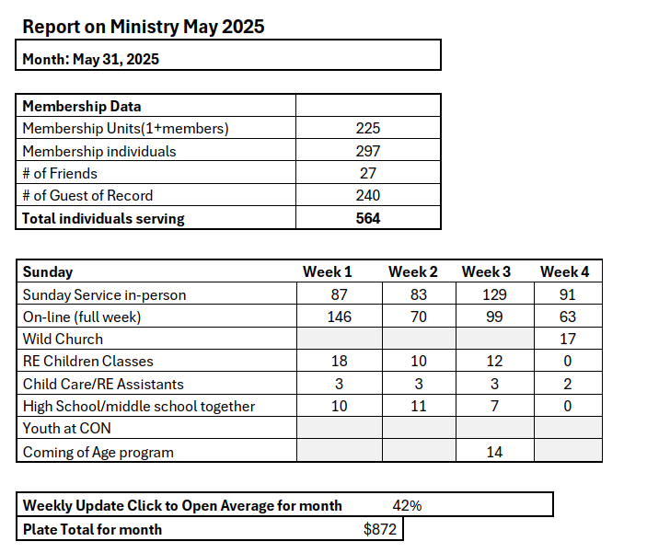
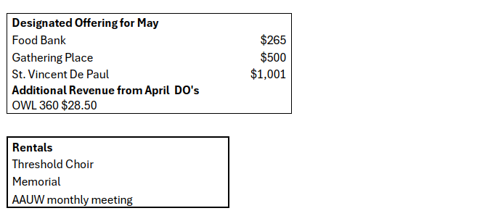
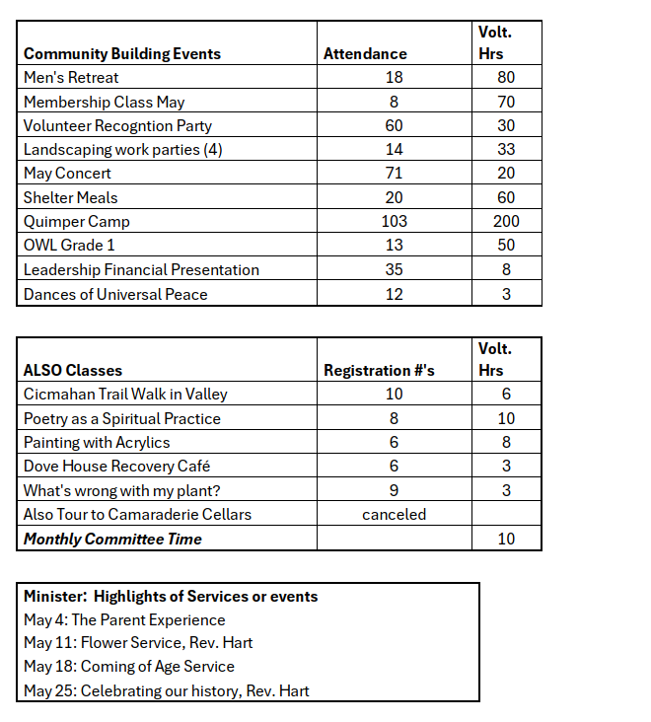
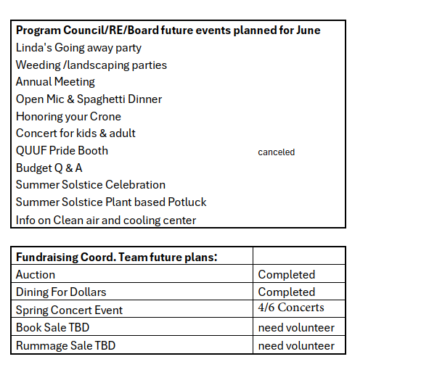

Attachment G
Governance Committee
Governance Committee Quarterly Board Report: June 2025
Submitted by Frances Loubere and Phil Burwell, Co-Chairs

Meeting Schedule: No July meeting. Next meeting Wednesday, August 13, 10-Noon. September onward -- first Wednesdays from 10 to noon. Beginning-of-year social gathering planned for late August/early September.

Members: Roseanna Almaee (Board), David Alvarez, Phil Burwell (Co-Chair), Julia Cochrane (Board Rep & Scribe), Jenell DeMatteo (QUUF Administrator), Diane Haas (PC liaison), Frances Loubere (Co-Chair), Christina Tweed (QUUF Tech), Anne Weaver. Rev. Linda Hart attended regularly – we will miss you! Frances and Phil will continue as co-chairs next year to provide stability during overall leadership uncertainty.

Anne Weaver Retires from GC: As a “founding member” (2019) we thank you, Anne, for your many contributions to GTF and GC.

Governance Structure Evaluation: We began this process with an internal GC review and continued by asking Board, Board Committee, and Program Council members to respond to evaluation questions. These answers were tallied and organized into categories and will be considered in 2025-26 when we’ll continue with the evaluation process.

Governance Education: Our Governance Power Point Presentation is being used in the new Board member orientation. We will reach out to share with additional QUUF committees, teams and councils in the fall.
Ministry Transition, Uncertainty and Governance Implications: GC forwarded to the Board a recommendation that the Ministry Coordinating Team be established to help fill the leadership gap following the departure of Rev. Linda. The GC offers assistance to the board where possible during this transition. We can, as a minimum, offer suggestions and comments on any relevant proposals the board may be considering and how they might impact governance.
Long Range Planning: GC members responded to a Board request for input. Suggestions were compiled and forwarded to the Board.

Bylaws Amendments: GC forwarded two amendments to the QUUF Bylaws to the Board to be considered for voting at the Annual Meeting Agenda.

Website Updates: Web pages for Shared Governance and the Governance Committee were updated prior to our interim minister search.

Nominating Committee Discussion: We began a discussion of the role of the Nominating Committee in governance. This will be continued next year with input from appropriate groups and may require a Bylaws change.
Return to Agenda

Attachment J
Agenda Items

Sarah Millspaugh | Tue, May 20, 12:58 PM
to me, Roseanna, Linda

Dear Rev. Linda, Sarah, and Roseanna,

I hope this note finds you well as you prepare for the conclusion of Rev Linda’s ministry at QUUF this summer. I am writing, as is customary at the end of a ministry, to schedule exit interviews with the board and departing minister. They can happen at any time between now and August when a new minister’s term might begin.

Here is the process: regional staff meets with the board, without the minister, and asks nine questions and records responses. Regional staff then meets with the minister and asks the same questions, recording the minister’s responses. The board and the minister then review what the staff drafted and provide corrections. Finally, copies of those interviews are shared with all parties and filed with the UUA’s Ministry and Faith Development Staff Group.

Here are the questions. It typically takes 1.5 hours for each interview.
1. What went well during this shared ministry?
2. What were the biggest challenges during this shared ministry?
3. What did you learn during this shared ministry?
4. Why did this ministry end?
5. How was conflict handled during the ministry?
6. How was the ministry shared between the minister, staff, and lay people?
7. Were there any cultural shifts in the congregation during this ministry?
8. What are your hopes for the future of this congregation’s ministry? Concerns?
9. Anything else you want the UUA to know?
Return to Agenda

